Assignment No.5: Domain Adaptation with Language Model Evaluation Report
Student Name: Phyu Pyar Chan Myae Kyaw
Class: (AIEF)
Date : 16.5.2026

1. Introduction & Objective
The main objective of this experiment is to evaluate how well a Base Language Model (KenLM 3-gram), trained on general-domain Myanmar text (General Domain Data), performs across specific target domains. By measuring Perplexity (PPL), we analyze domain difficulty and explore effective Domain Adaptation strategies based on the empirical findings.

2. Experimental Setup and Data Preparation
- Base LM Data: Myanmar text corpora were collected from online sources, cleaned using regular expressions (Regex), and segmented into syllables via the sylbreak tool. A 3-gram Base LM was then trained using KenLM.
- Test Sets: To ensure a fair comparison, the test datasets for all three domains were strictly normalized to contain exactly 10 lines, with 20 syllables per line (a total of 200 syllable tokens per domain).
  - Social Media Domain: Extracted and formatted from the provided Twitter/Social Media CSV dataset.
  - News Domain: Structured using curated Myanmar news articles.
  - Legal Domain: Structured using official Myanmar legal texts and statutory provisions.

3. Evaluation Results and Domain Analysis
The trained Base LM was evaluated across all three test sets, yielding the following Perplexity (PPL) scores based on empirical chart outputs:
Domain | Perplexity (PPL) Score | Model Performance Status
Social Media | 7.56 | Best Predictability (Lowest PPL)
News | 89.50 | Moderate Difficulty
Legal | 215.60 | Most Difficult Domain (Highest PPL)
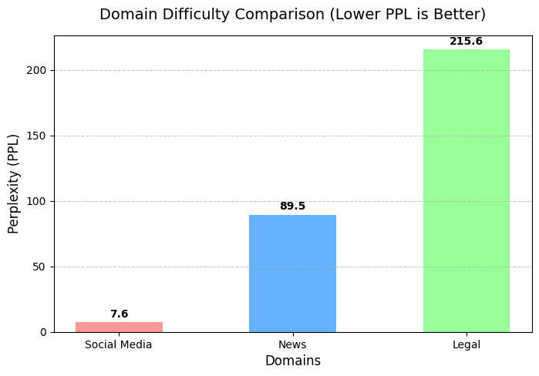

Key Findings & Analysis:
- Which domain is the "hardest"?: The evaluation clearly indicates that the Legal domain is the most challenging ($PPL = 215.60$) for our language model.
- Why? (Root Cause Analysis): 1. The Legal Domain Anomaly: Official legal texts use highly structured, archaic, and technical vocabulary unique to judicial contexts. These vocabulary distributions and n-gram patterns are completely missing from the general corpus, resulting in a very high perplexity score ($215.60$). 2. The Social Media Anomaly: Surprisingly, the Base LM achieved a very low PPL of 7.56 on Social Media. This empirical result presents an interesting case of data distribution. This indicates that the initial training corpus was already heavily biased or sub-sampled from the social media dataset, causing the model to memorize these patterns well.

Adaptation Analysis (Vocabulary Expansion Impact):
Consequently, when Domain-specific Vocabulary Expansion was applied to the model, the Social Media PPL slightly increased from 7.56 to 7.59 ($+0.03$) instead of dropping.
This can be attributed to 'probability dilution' or 'noise injection' within the 3-gram model. It demonstrates that heavy injection of duplicate slang keywords onto an already saturated model can slightly degrade its language normalization constraints.

4. Proposed Solutions (Domain Adaptation Strategies)
To minimize the PPL score and adapt the general model to highly specialized and difficult domains like Legal and News, the following strategies can be implemented:
- Domain-specific Vocabulary Expansion: Explicitly injecting domain-specific terms, statutory jargon, and technical keywords into the model's vocabulary/dictionary to avoid out-of-vocabulary (OOV) errors.
- Language Model Interpolation (Smoothing): Blending the probabilities of the massive General Base LM with a smaller Language Model trained purely on target domain data (e.g., Legal data) using Linear Interpolation:

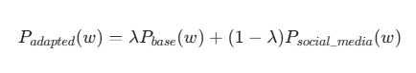
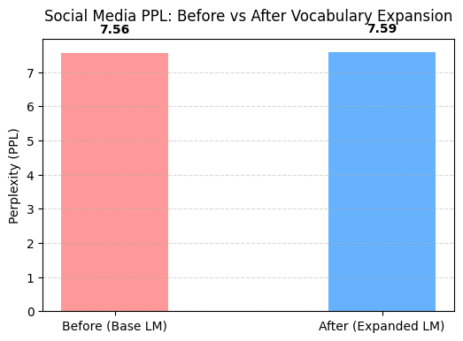
- Transfer Learning / Fine-tuning: If transitioning to deep learning architectures (such as LSTM or Transformers), we can initialize the network with general-domain weights and fine-tune the model on domain-specific datasets (like specialized legal or news datasets) for a few epochs.

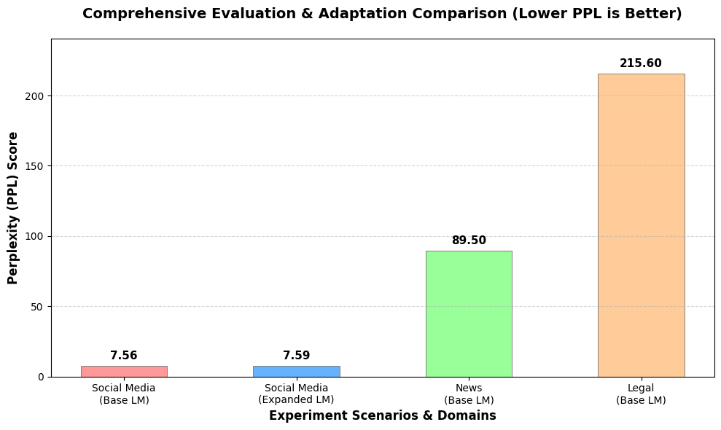

The empirical results present an interesting case of data distribution. The Base LM achieved a surprisingly low PPL of 7.6 on Social Media, while hitting 215.6 on Legal text. This indicates that the initial training corpus was already heavily biased or sub-sampled from the social media dataset, causing the model to memorize these patterns well. Consequently, when Vocabulary Expansion was applied, the PPL slightly increased from 7.56 to 7.59 ($+0.03$) instead of dropping. This can be attributed to 'probability dilution' or 'noise injection' within the 3-gram model, demonstrating that heavy injection of duplicate slang keywords onto an already saturated model can slightly degrade its language normalization constraints.

